Game Story

A spaceship was launched and an alien was catching the spaceship ,many obstacles are there in the space to stop the spaceship from reaching the moon.

Playing characters- Spaceship

Non Playing characters- Alien,asteroids,fuel

Goal-when the spaceship collides with moon surface spaceship will be safe

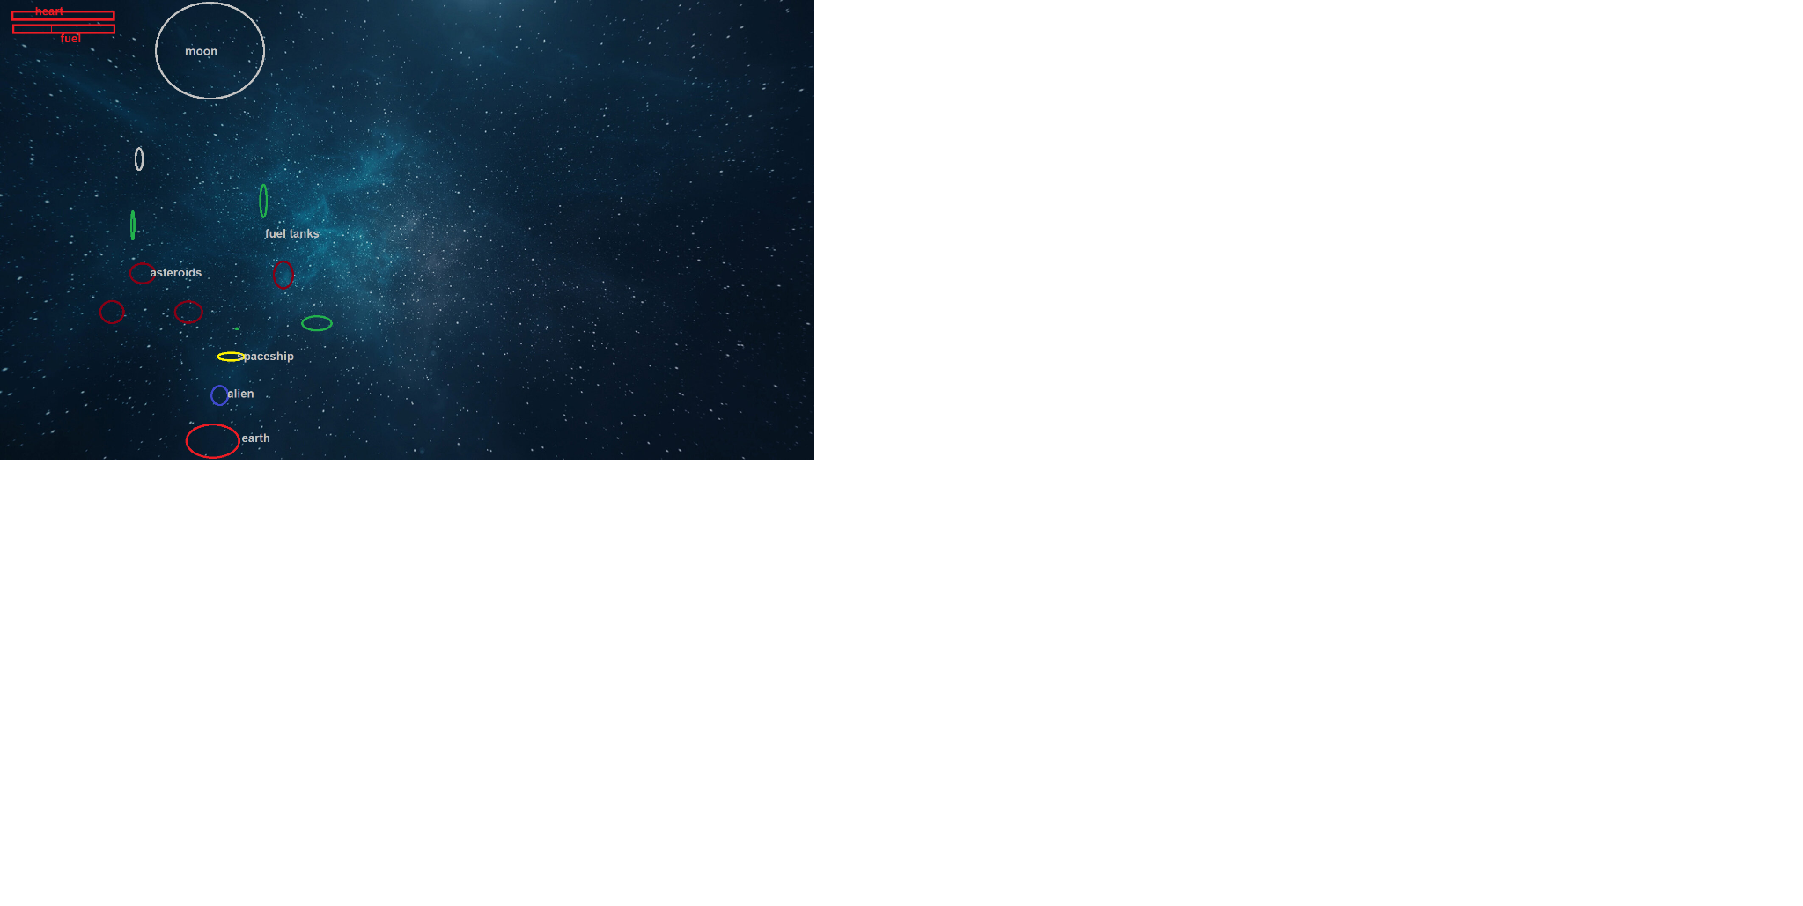

Player controls- up arrow key,left arrow key,right arrow key

Rules- if a spaceship hits the asteroid life will decrease,if the spaceship collides with fuel tanks it will increase fuel bar once fuel bar gets 100% life will increase.

Balance component-Spaceship will get shield for 2-3 sec.teleportation 100km.

Adaptivity-asteroids speed will increase as u go further

Feedback-health bar,fuel bar,earth-moon distance

Chance vs skill- asteroids will spawn randomly,getting fuel and shield